Operation Manual
HM5002-10A Transformer DC Winding Resistance Tester
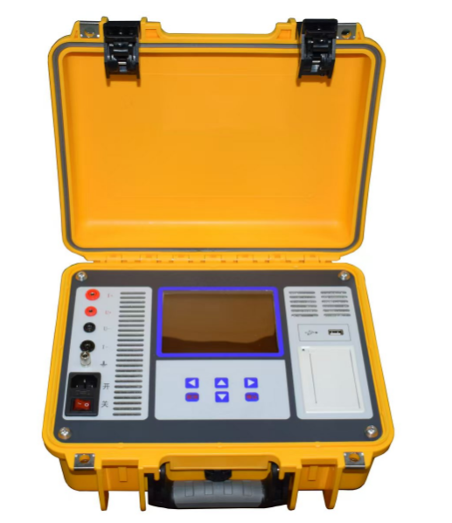

WUHAN GOLDHOME HIPOT ELECTRICAL CO.,LTD
Tel.：+86-13720185294 Fax：+86-27-84625205
Email：goldhome02@cablehipot.com Web.: www.hvcablehipot.com
Add.: No.A25-1, Huading Mould Industrial Park, Hannan, Wuhan, Hubei, China

Statement
Copyright Statement
No content in this manual may be reproduced in any form (including but not limited to electronic storage, retrieval or translation into other national or regional languages) without the permission and written consent of the Company.
Ver1.00

Content
1 Overview 1
2 Packaging 1
3 Functional Features 1
4 Technical Indiactors 2
5 Appearance 3
6 Instructions 4
7 Precautions 8
8 After-sales Service 8

1 Overview
The DC resistance of transformers must be tested for their delivery, installation and handover, regardless they’re semi-finished or finished transformers. It’s also indispensable in preventive tests for power sector. In this way, manufacturing defects like coil material, welding, loose connection, lack of strands and disconnection can be detected and hidden dangers after it’s put into use can be predicted.
As an innovative product, the DC resistance tester is small and portable. It boasts fast testing and high accuracy, suitable for the test of both inductive samples like transformers, mutual inductors and reactors as well as that of resistive samples like copper bars, wires and switch contacts.

2 Packaging
Open the packaging box to check if it’s damaged after receiving the delivery. If the box is damaged or its inner padding is indented, please inform the shipping company and the nearest sales office of our company.
Please check if the following items are delivered:
Standard Version:
√ 1 tester
√ 1 set of test wires (one in red and one in black)
√ 1 ground wire
√ 1 three-core power cord
√ 3 fuses (2A)
√ 2 rolls of printing paper
√ 1 User’s Manual (printed)
√ 1 Delivery Test Report
√ 1 Qualification Certificate/Warranty Card

3 Functional Features
◆ Easy and fast to use with 6 gears of currents (maximum current is 10A) supporting automatic selection.
◆ Wide measurement range (500uΩ ~ 50kΩ) and high accuracy.
◆ Resistance and temperature conversion.
◆ Protecting from back electromotive force, disconnection, power failure, overheating, etc.
◆ 5.6-inch super-large industrial high-brightness color LCD screen which can be read clearly even under strong sunlight.
◆ Equipped with printer for easy data printing.
◆ Data storage in tester or in USB disk.

4 Technical Indicators
DC Resistance Test
Gear Of Currents | Measurement Range | Gear Of Currents | Measurement Range
10A | 500uΩ ～ 200mΩ | 100mA | 10Ω ～ 200Ω
5A | 10mΩ ～ 1Ω | 10mA | 50Ω ～ 2kΩ
1A | 100mΩ ～ 20Ω | 1mA | 500Ω ～ 50kΩ
Technical Indicators
Accuracy | ±(reading×0.2%+2) | Maximum Highest Resolution | 0.1uΩ
Using Conditions & Appearance
Power Supply | AC220±10% | Power Frequency | 50/60Hz
Temperature | -10℃ ～ 50℃ | Relative Humidity | ≤90%, non-condensing
Weight | 3.6kg (test wires not included) | Dimension | 325mm(L)×225mm(W) ×125mm(H)

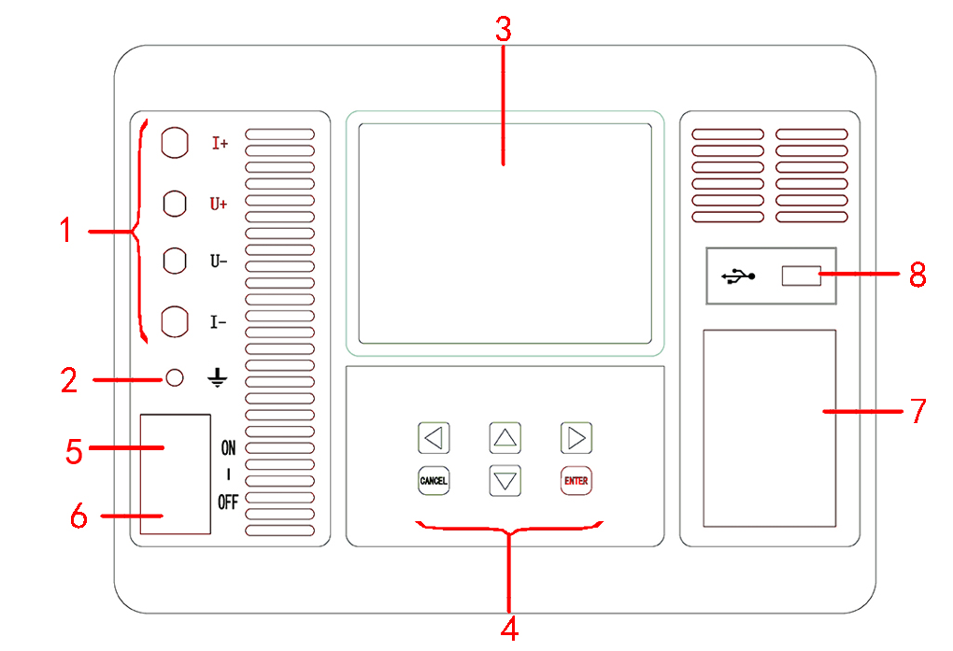
5 Appearance

Function Module | Description
- Test Wire Connection | It refers to the red and black terminals where one end of the red and black test wires connects I+, U+, U- and I- respectively and the other end, the red and black clamps, connects the tested product.
- Ground Terminal | Sound grounding must be ensured. No paint or rust should be on ground connection area.
- Screen | It refers to 5.6-inch super-large industrial high-brightness color LCD screen which shows operating menu and test results.
- Button | It’s used to operate the tester. Pressto go up, down, left and right respectively or modify data. Press “ENTER” to confirm the current operation. Press “CANCEL” to cancel the current operation.
- Power Interface | AC220V.
- Power Switch | I t refers to power switch of the whole tester.
- Printer | It’s used to print test reports.
- USB Interface | Insert FAT or FAT32 format USB disk here to store test data. During storage, don’t take it off.

6 Instructions
◆ Connecting Test Wires
Connect one end of test wires, that is, the red and black clamps with both ends of tested products. Connect the other end of test wires with binding posts according to color.
◆ Instructions On Printer
The printer’s button and its indicator light are integrated. After the printer is powered on, the indicator light will be on all the time under normal conditions and it’ll flash when printing paper is used up. Press button once and paper will be fed.
Changing Printing paper:
Pull out rotating handle and open cover. Load printing paper and pull out the paper a little (outside tearing teeth a little). Ensure that the paper is put neatly and the side with chemical (the smooth side) is upward. Close the cover. After the paper is held tightly by shaft, push the shaft into print head and push in the rotating handle to restore the original state.
◆ Instructions On Menu
After all test wires are connected, turn on power switch. The tester is initialized and goes to "main menu" interface, as shown below.
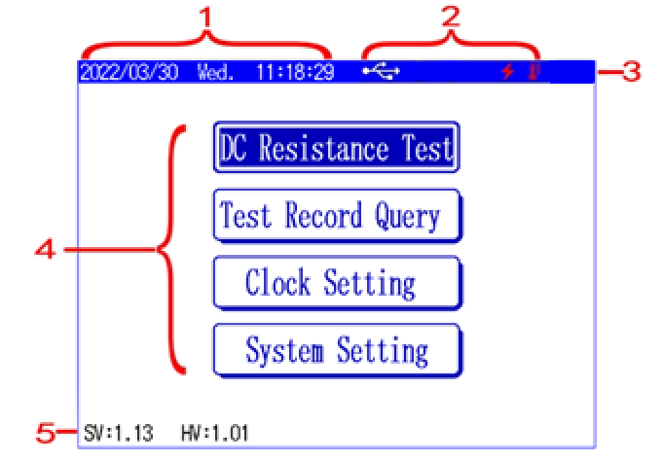

No. | Description
1 | Here data and time are shown.
2 | Here current peripherals and operations are shown.
 | This icon is shown when a USB disk is inserted.
 | This icon is shown and keeps flashing during test.
 | This icon is shown when the tester is overheated. Stop testing when red light is flashing.
3 | The main menu is shown here. Press up or down button to select functions. Press yes button to enter setting of the function.
 | It refers to DC Resistance Testing. Both inductive samples like transformers, mutual inductors and reactors as well as resistive samples like copper bars, wires, switch contacts can be tested.
 | It refers to Test Result Query.  All sets of data in testing can be accessed. Operations like data printing and data transferring to USB disk can be done on interface of storage and query.
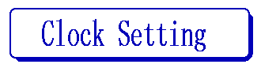 | It refers to Clock Setting. Here time and date can be set.
 | It refers to System Parameter Setting. Password is required for operation and it’s not open to users.
4 | SV refers to the current software version No. of the tester.  HV refers to the current hardware version No. of the tester.

Select to enter the interface of DC resistance parameter setting, as shown below.

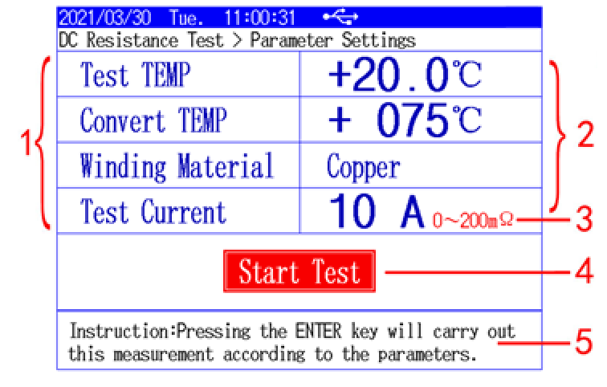

No. | Description
1 | Here is the first-level operation directory. Press up or down button to select functions. After function has been selected, press left or right button to set parameters of the function.      Tip: In the first-level operation directory, you can press yes button to quickly move cursor to and quickly start testing.
Test TEMP | It refers to Test Temperature. It means the current temperature of the tested product, ranging from -99 ℃ to 99 ℃.
Convert TEMP | It refers to Converted Temperature. Here we can set the temperature we want to convert. The converted temperature ranges from 0 ℃ to +255 ℃. This value is very vital to accuracy.
Winding Material | It refers to Winding Material.  The winding material can be selected as copper or aluminum, which relates with converted coefficient of resistance.
Test Current | It refers to Test Current. Gear of currents for tests ranges from 1mA, 10mA, 0.1A, 1A, 5A, 10A to automatic.
2 | Here is the second-level operation directory, which is same with the first-level operation directory in setting parameters. Press left or right button to move cursor. Press up or down button to set parameters.  Tip: In the secondary operation directory, Press yes or no button to quickly move cursor to the first-level operation directory.
3 | It shows the measurement range under the current test current.
4 | When cursor is here, press yes button to start testing.
5 | It refers to description of the selected function. Here it says gear of currents is adopted in this test.
The interface “DC Resistance Test Result” is shown below.
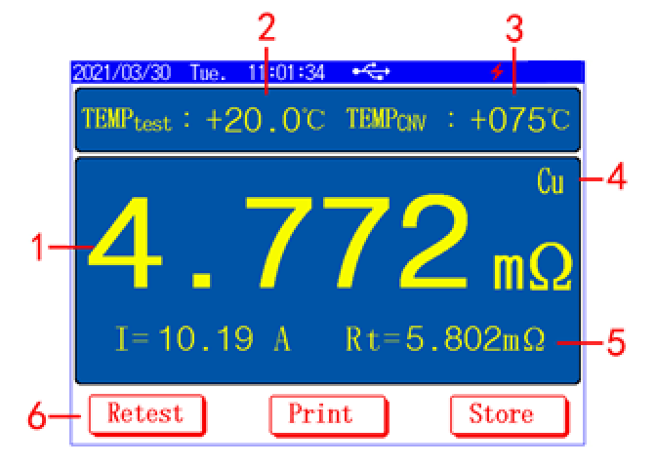

No. | Description
1 | The resistance value measured in test is shown here.
2 | It refers to the temperature of the tested product when windings of one side are tested.
3 | It refers to the temperature value that needs to be converted.
4 | Winding material.
5 | Here shows the resistance value after temperature conversion.
6 | Here is menu selection area.  Press left or right button to move cursor to select corresponding function. Press Yes button to execute currently selected function. Press No button to return to previous interface.
 | It refers to Retest. It means to retest under current setting.
 | It refers to Data Printing. It means to print the current test results by printer.
 | It refers to Data Storage. It means to save the current test result to the tester or to an external USB disk.  Tips: The data saved to the USB disk is in WORD format and can be opened directly in OFFICE for editing or printing.

7 Precautions
For testing windings of no-load regulating transformers, don’t switch off no-load tap changer during tests or power discharge.
Don’t disconnect test wires and cut off power switch during test or power discharging.
During transformer tests, windings of the unmeasured side must be in open circuit.

8 After-sales Service
8.1 Warranty card is included in the delivery of this product, so during delivery, please check the product carefully on the spot. If defects are found, please fill in the warranty card carefully.
8.2 Buyers enjoy lifelong maintenance from the date of purchase. They can show its warranty card for free repairing if problems happen within warranty period, otherwise, they have to pay for repairing and commissioning.
8.3 The following conditions are not in warranty:
8.3.1 Products are disassembled or their structure is changed by users deliberately.
8.3.2 Products are seriously damaged due to users’ improper storage or use.
8.3.3 Products are damaged for other reasons on user side.

